The University Of Azad Jammu & Kashmir,
Muzaffarabad.


Department of Software Engineering

Group Project

- Deep Learning
Course Code: SE-3210

Submitted To:
Engr. Ahmed Khawaja

Submitted By:
Group Members
- Sabaat Ali(2023-SE- 22)
- Atif Gull (2023-SE-26)
- Muhammad Fayaz(2023-SE-23)

Table of Contents

1. Introduction and Research Motivation
2. Problem Definition and Objectives
3. Dataset and Data Preparation
4. Literature and Technical Foundations
5. Proposed Advanced Architecture
6. Model Components and Mathematical Formulation
7. Training and Inference Procedure
8. Experimental Setup and Evaluation
9. Results and Performance Analysis
10. Limitations and Threats to Validity
11. Challenges and Engineering Solutions
12. Conclusion and Future Work
References.
Appendix A. Configuration Tables
Appendix B. Selected Code and Reproducibility Notes

BIRDCLEF+ 2026
MULTI-MODEL BIOACOUSTIC
RECOGNITION FRAMEWORK
Transfer Learning, Temporal State-Space Modeling,
Contextual Priors and Rank-Space Ensemble Fusion

Executive Summary
This enhanced report presents a structured and technically detailed study of a multi-label bioacoustic recognition pipeline developed for BirdCLEF+ 2026. The task is to process 60-second continuous soundscape recordings, divide each recording into twelve non-overlapping five-second windows, and estimate the presence of 234 target taxa for every window. The documented system combines frozen Perch V2 representations, selective state-space sequence models, metadata-aware contextual priors, class-specific MLP probes, a five-fold sound-event-detection branch, BirdNET V2.4, and percentile rank-space ensemble fusion.
The most important documented performance result is a public leaderboard score of 0.94727, compared with a previous best of 0.48813. Because the competition metric is macro-averaged ROC AUC, this value should be reported as an AUC/leaderboard score rather than ordinary classification accuracy. Expressed as a percentage, 0.94727 corresponds to 94.727% of the AUC scale; it does not mean that 94.727% of individual predictions were correct. The source report explicitly notes that the final configuration bundled several changes, so the individual contribution of each component was not isolated.

Metric / Result | Documented value | Interpretation
Target taxa | 234 | Output vocabulary
Recording duration | 60 s | One soundscape example
Windows per recording | 12 | 5 s per window
Sampling rate | 32 kHz | Audio processing setting
Evaluation metric | Macro ROC AUC | Class-balanced ranking metric
Previous best score | 0.48813 | Documented baseline
Final public score | 0.94727 | Documented final result
Final score as percentage | 94.727% | AUC scale, not prediction accuracy
Public rank | 1543 | Competition leaderboard position
Table 1. Executive performance and task summary.
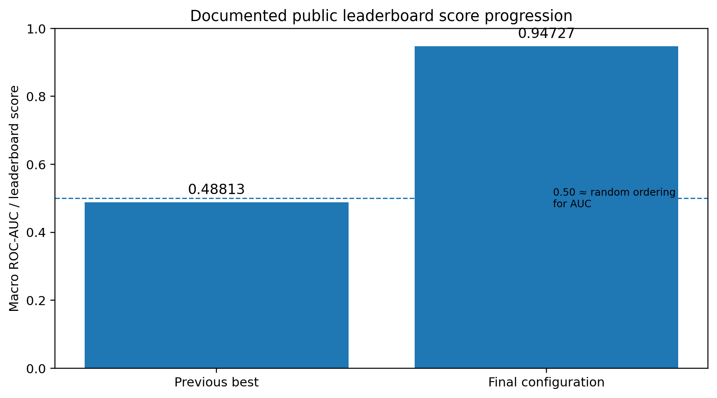
Figure 1. Documented public leaderboard score progression; no new experimental score is fabricated.

1. Introduction and Research Motivation

1.1 Background
Passive acoustic monitoring provides a scalable way to collect ecological observations without continuous human presence. Autonomous recording units can capture long periods of environmental audio, but the resulting data volume creates a severe annotation bottleneck. BirdCLEF+ frames this problem as machine listening: an automated system must identify which taxa are acoustically present in short temporal windows.

1.2 Why the Problem Is Difficult
- Environmental recordings contain wind, rain, insects, water, aircraft and human-generated noise.
- Multiple taxa can vocalise simultaneously, making the task multi-label rather than single-label.
- Vocalisations can be short and sparse, so a five-second window may contain only a small informative event.
- The label distribution is long-tailed, with some taxa having far fewer positive examples than common taxa.
- The macro-AUC evaluation gives each supported class influence on the final metric, making rare-class coverage important.

1.3 Research Motivation
The central design principle is to avoid relearning general acoustic representations when a strong bird-domain backbone is already available. Instead, the project learns compact task-specific heads and sequence models over frozen embeddings and combines independent detectors at inference time.

2. Problem Definition and Objectives
Let a recording be divided into T = 12 windows and let C = 234 be the target taxonomy size. The model produces a score p(t,c) for each window t and class c. The competition evaluates class-wise ROC AUC and then averages across classes with positive support.
Conceptually:
Macro-AUC = (1 / |C⁺|) × Σ AUC(c), where C⁺ contains classes with positive support.
This distinction is important for reporting: a high AUC means the system tends to rank positive windows above negative windows. It is not equivalent to the percentage of labels classified correctly at a fixed threshold.
Objective | Description
Complete inference pipeline | Convert raw soundscapes into valid 234-class window predictions.
Transfer learning | Reuse frozen Perch V2 bioacoustic representations.
Temporal modeling | Capture relationships among the twelve windows.
Context integration | Use site and recording hour as additional information.
Heterogeneous ensembling | Combine independent acoustic detectors robustly.
Engineering reliability | Validate row identifiers, columns, ranges and missing values before submission.
Table 2. Project objectives.

3. Dataset and Data Preparation

3.1 Dataset Characteristics
Property | Value | Role in the pipeline
Target taxa | 234 | Final class vocabulary
Recording length | 60 seconds | Input soundscape
Window length | 5 seconds | Temporal prediction unit
Windows/file | 12 | Sequence length
Sampling rate | 32,000 Hz | Audio processing
Samples/window | 160,000 | Raw samples before feature extraction
Format | OGG Vorbis, mono after averaging | Input representation
Task type | Multi-label | Several taxa may be active in one window
Evaluation | Macro ROC AUC | Primary documented metric

3.2 Windowing Strategy
Each 60-second recording is represented as twelve consecutive non-overlapping five-second windows. This design creates a compact sequence suitable for state-space modeling while preserving the temporal structure of the original recording.
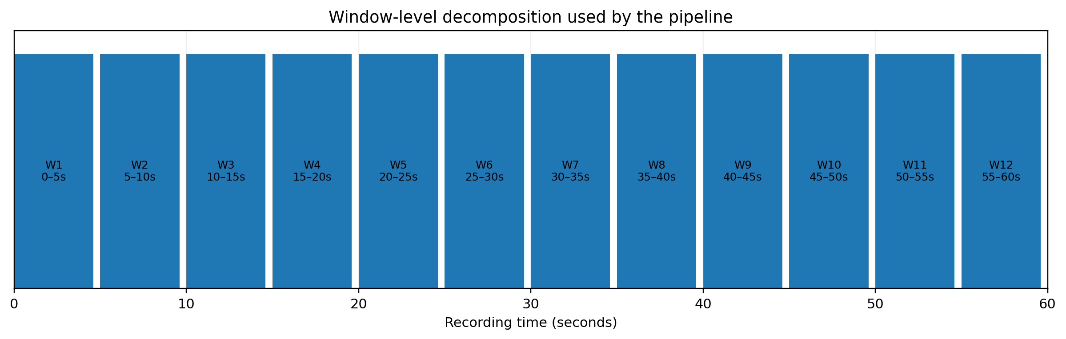
Figure 2. Twelve-window decomposition of a 60-second soundscape.

3.3 Label Construction
Training annotations are aggregated by interval and converted to a binary matrix with one row per window and 234 class columns. The row identifier is constructed consistently from the filename stem and window end time. Files without complete window-level labels are excluded from sequence-model training so unknown labels are not incorrectly treated as negative examples.

3.4 Class Imbalance
The source report describes a highly imbalanced class distribution. The pipeline therefore uses capped positive weights, frequency-aware training strategies and dedicated probes for low-support classes. Since the final report does not provide a complete per-class support table, exact class frequencies are not invented here.

4. Literature and Technical Foundations

4.1 Domain-Specific Audio Embeddings
Perch V2 is used as a frozen domain-specific feature extractor. The motivation is that representations learned from bird vocalisations can encode useful acoustic distinctions that are difficult to learn from a modest downstream dataset.

4.2 Selective State-Space Models
State-space sequence models provide a mechanism for processing ordered observations while maintaining a hidden state. The project uses a simplified bidirectional selective SSM to model dependencies among the twelve soundscape windows.

4.3 Prototype-Based Classification
Instead of relying only on an unconstrained linear classifier, the LightProtoSSM head represents each class through a learnable prototype in the embedding space. Normalized similarity between a window representation and class prototypes provides class evidence.

4.4 Sound Event Detection and BirdNET
The final ensemble incorporates a five-fold SED branch and BirdNET V2.4. These sources provide complementary acoustic evidence and reduce dependence on a single score distribution.

4.5 Rank-Space Fusion
Probability scales from heterogeneous models are not necessarily comparable. The final system therefore converts scores into within-class percentile ranks and combines the ranks using fixed blend weights.

5. Proposed Advanced Architecture
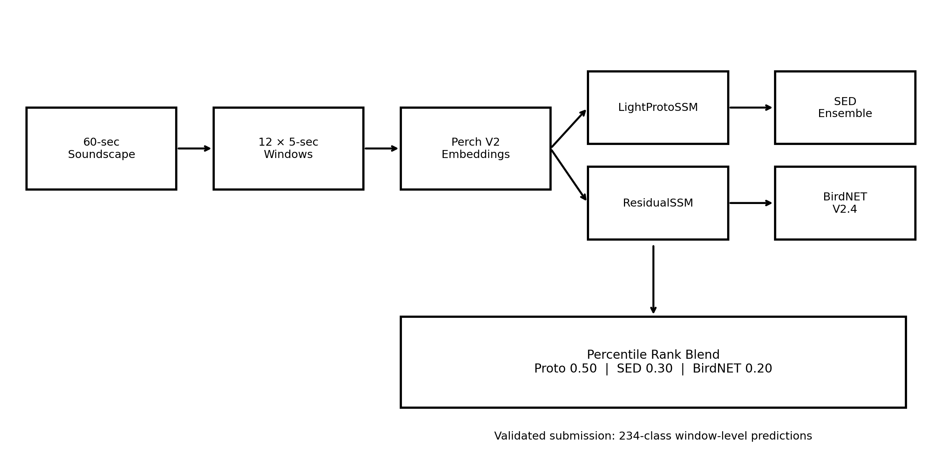
Figure 3. Advanced multi-stage architecture derived from the documented pipeline.
The proposed report architecture contains six logical stages: audio segmentation, frozen representation extraction, temporal sequence modeling, independent detector inference, rank-space fusion, and output validation. The architecture is designed around the competition metric and the need for reliable class coverage.
Stage | Input | Output | Purpose
1. Segmentation | 60-s audio | 12 × 5-s windows | Create temporal units
2. Perch V2 | 5-s windows | Embeddings + backbone logits | Domain-specific representation
3. Proto/SSM stack | Embeddings + metadata | Class scores | Model temporal context
4. SED / BirdNET | Audio windows | Independent scores | Complementary evidence
5. Rank blending | Three score sources | Final ranking | Reduce scale mismatch
6. Validation | Final matrix | Submission file | Prevent formatting/alignment errors
Table 3. End-to-end architecture.

6. Model Components and Mathematical Formulation

6.1 LightProtoSSM
LightProtoSSM projects the embedding sequence into a model space, adds positional and metadata information, processes the sequence through bidirectional SSM layers, optionally applies self-attention, and computes normalized prototype similarities. A per-class fusion parameter then combines the learned similarity score with the frozen backbone logits.
s(t,c) = α(c) · proto_score(t,c) + [1 − α(c)] · backbone_logit(t,c)

6.2 ResidualSSM
The second SSM learns a bounded correction to the first-pass output. Its correction strength is configured as 0.30, and the output head is zero-initialized so that the second stage initially behaves like an identity correction.

6.3 Contextual Priors
Recording site and UTC hour are extracted from the filename convention. These variables represent ecological context because species composition and vocal activity can vary by location and time of day. The prior is shrunk toward broader statistics to reduce instability for sparse groups.

6.4 MLP Probes
Additional class-specific MLP probes operate on PCA-reduced embeddings augmented with temporal context. The final configuration uses 128 PCA components and a minimum positive support of three.

6.5 Rank-Space Ensemble
The final documented three-way blend uses 0.50 for the Proto/SSM branch, 0.30 for SED and 0.20 for BirdNET. These are blend weights, not measured percentages of contribution.
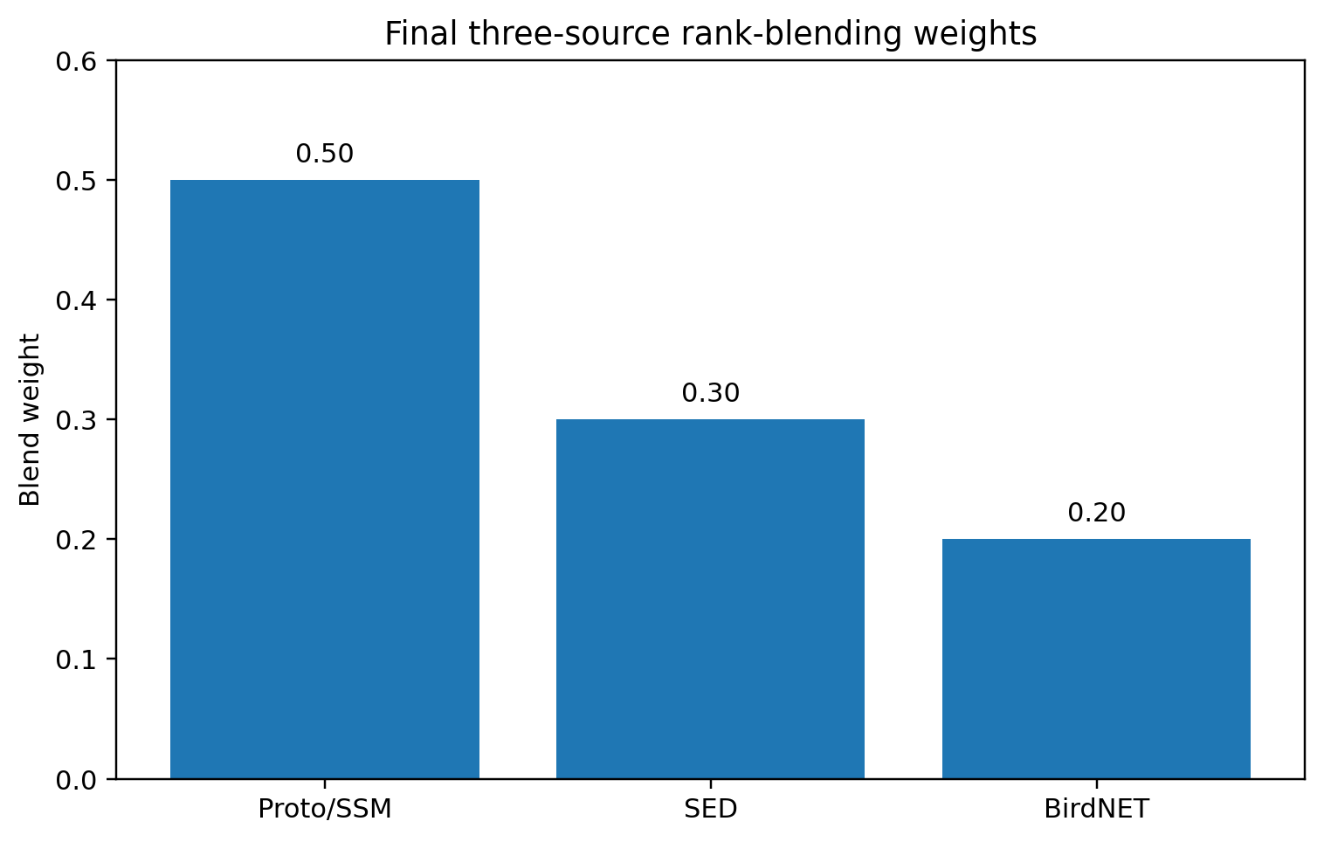
Figure 4. Final three-source ensemble weights. These values are configured blend weights, not accuracy contributions.
Component | Configured value | Interpretation
Proto/SSM branch | 0.50 | Largest blend weight
SED branch | 0.30 | Second independent acoustic source
BirdNET | 0.20 | Third independent detector
Table 4. Documented ensemble weights.

7. Training and Inference Procedure

7.1 Training Objective
The reported LightProtoSSM training objective combines positive-weighted binary cross entropy with a distillation term toward the Perch logits. The positive-weight cap is 25.0 and the distillation coefficient is 0.15.
Loss = Weighted BCE(logits, labels) + 0.15 × MSE(logits, Perch logits)

7.2 Inference Sequence
Step | Operation | Quality control
1 | Discover and load required model/data artefacts | Path checks and fallback discovery
2 | Split recordings into 5-s windows | Exactly 12 windows per 60-s recording
3 | Generate/cache Perch V2 outputs | Cache consistency check
4 | Run LightProtoSSM and ResidualSSM | Sequence and metadata alignment
5 | Run SED and BirdNET | Independent detector outputs
6 | Convert scores to ranks | Within-class ranking
7 | Apply blend and arbitration gates | Final ensemble score
8 | Validate submission | IDs, columns, finite values and [0,1] range
Table 5. Inference and validation workflow.

8. Experimental Setup and Evaluation

8.1 Evaluation Metric
ROC AUC measures ranking quality across thresholds. AUC = 0.5 represents random ordering, while larger values indicate better separation of positive and negative examples. Because the competition averages AUC across classes, the reported score is a macro-level ranking metric.

8.2 Documented Results
Evaluation item | Value | Status
Previous best public score | 0.48813 | Documented
Final public leaderboard score | 0.94727 | Documented
Final score on 0–100 scale | 94.727% | Equivalent AUC scale
Public leaderboard rank | 1543 | Documented
Number of recorded submissions | 6 | Documented in source report
Table 6. Documented evaluation results.
Important reporting note: the report does not provide a conventional test-set accuracy, precision, recall, F1-score, or confusion matrix. Therefore, these metrics are not fabricated. The appropriate headline performance value is the documented macro ROC-AUC leaderboard score of 0.94727.

8.3 Accuracy Interpretation
Term | Reported value | Correct interpretation
AUC score | 0.94727 | High ranking score on the competition's AUC scale
AUC percentage | 94.727% | 0.94727 × 100; not classification accuracy
Classification accuracy | Not reported | Cannot be derived from AUC alone
F1-score | Not reported | Requires thresholded predictions and labels
Confusion matrix | Not reported | Requires thresholded class decisions
Table 7. Accuracy versus AUC clarification.

9. Results and Performance Analysis

9.1 Score Improvement
The documented score increased from 0.48813 to 0.94727. The source report cautions that the improvement should not be interpreted as an isolated gain from one neural architecture because several changes were bundled into the final submission. The report attributes the major improvement primarily to correct and complete label-space coverage and correct row alignment, with architectural and statistical refinements contributing secondarily.
Absolute score change = 0.45914 AUC points. This is an increase of 45.914 percentage points on the AUC scale.
Change introduced | Reason | Individually measured?
ProtoSSM epochs 40 → 80; patience 8 → 15 | Allow longer optimization and SWA phase | No
MLP support 5 → 3; PCA 64 → 128 | Cover more low-support classes and retain more variance | No
Two-way → three-way blend | Add BirdNET as an independent detector | No
Table 8. Final-iteration changes documented by the source report.

9.2 What the Result Does and Does Not Prove
- The final pipeline produced a strong documented public leaderboard score of 0.94727.
- The result supports the effectiveness of the complete submitted pipeline on the public leaderboard.
- The result does not isolate the contribution of Perch V2, SSMs, SED, BirdNET, contextual priors or probes individually.
- A public leaderboard score is not equivalent to an independently validated scientific test-set accuracy.
- The source report identifies threshold calibration and lack of isolated ablations as methodological limitations.

9.3 Qualitative Findings
Finding | Evidence/interpretation from project
Label-space coverage | Identified as a major factor in moving the system away from near-random class ordering.
Row alignment | A correctness requirement because mismatched IDs can silently destroy AUC.
Rank blending | More robust than directly averaging heterogeneous probability scales.
Adaptive smoothing | Preferred over uniform smoothing for preserving short isolated calls.
Zero-initialized residual | Provides a safe second-stage correction at initialization.
Table 9. Qualitative analysis of the documented pipeline.

10. Limitations and Threats to Validity
- Threshold calibration used predictions from training data rather than fully independent grouped out-of-fold predictions.
- Several regularizers were configured but were not active in the training loop that produced the reported result.
- The public leaderboard exposes only a single aggregate score, limiting controlled ablation analysis.
- The final configuration changed multiple components simultaneously, preventing reliable attribution of individual gains.
- The report does not provide a conventional accuracy percentage or per-class confusion matrix.

10.1 Reproducibility Risk
A robust scientific evaluation should use grouped cross-validation by recording file, preserve strict separation between training and validation recordings, and calculate thresholds and ensemble weights only from out-of-fold predictions.

11. Challenges and Engineering Solutions
Challenge | Risk | Implemented solution
Dataset/model paths | Runtime failure or missing artefacts | Recursive discovery and fallback logic
Cache inconsistency | Stale or mismatched embeddings | Identifier consistency checks
Row-ID mismatch | Silent prediction/target misalignment | Shared identifier construction and reindexing
Dry-run environment | Empty test directory | Substitute controlled training examples for pipeline execution
Output formatting | Invalid competition submission | Column, ID, finite-value and range assertions

12. Conclusion and Future Work
This enhanced report documents a complete multi-model bioacoustic recognition system for BirdCLEF+ 2026. The architecture combines frozen domain-specific embeddings, temporal state-space modeling, prototype-based classification, contextual priors, independent SED and BirdNET detectors, and rank-space ensemble fusion. The documented final public leaderboard score is 0.94727, compared with a previous best of 0.48813.
The central lesson is that reliable label coverage, identifier alignment and evaluation-aware engineering can be as important as architectural complexity. The reported result should be described as a macro ROC-AUC leaderboard score, not as ordinary classification accuracy.

12.1 Future Work
- Use grouped cross-validation by recording file.
- Calibrate thresholds and blend weights from out-of-fold predictions.
- Measure each architectural component through controlled ablation experiments.
- Activate and independently evaluate configured regularizers such as mixup, focal loss and label smoothing.
- Investigate learned per-class ensemble weights.
- Use conservative pseudo-labelling for unannotated soundscapes.
- Report per-class AUC and rare-class performance in addition to the macro average.
- Add thresholded accuracy, precision, recall and F1 only when an explicit validation threshold is defined.

References
- Gu, A., Goel, K. and Ré, C. (2022). Efficiently Modeling Long Sequences with Structured State Spaces. ICLR.
- Gu, A. and Dao, T. (2023). Mamba: Linear-Time Sequence Modeling with Selective State Spaces. arXiv:2312.00752.
- Hamer, J. et al. (2023). BIRB: A Generalization Benchmark for Information Retrieval in Bioacoustics.
- Kahl, S., Wood, C. M., Eibl, M. and Klinck, H. (2021). BirdNET: A Deep Learning Solution for Avian Diversity Monitoring. Ecological Informatics, 61, 101236.
- Kong, Q. et al. (2020). PANNs: Large-Scale Pretrained Audio Neural Networks for Audio Pattern Recognition. IEEE/ACM TASLP, 28, 2880–2894.
- Lin, T.-Y. et al. (2017). Focal Loss for Dense Object Detection. ICCV.
- Snell, J., Swersky, K. and Zemel, R. (2017). Prototypical Networks for Few-Shot Learning. NeurIPS.
- Vaswani, A. et al. (2017). Attention Is All You Need. NeurIPS.
- Zhang, H. et al. (2018). mixup: Beyond Empirical Risk Minimization. ICLR.
- LifeCLEF / Kaggle (2026). BirdCLEF+ 2026 Competition.

Appendix A — Configuration Tables
LightProtoSSM parameter | Value
Model dimension | 128
State dimension | 16
Bidirectional SSM layers | 2
Cross-attention heads | 2
Dropout | 0.15
Site embedding | 16
Hour embedding | 16
Epochs / patience | 80 / 15
Learning rate | 8e-4 to 1e-3
Weight decay | 1e-3
Positive-weight cap | 25.0
Distillation weight | 0.15
Gradient clipping | 1.0
Table A1. LightProtoSSM configuration.
Post-processing / ensemble parameter | Value
PCA components | 128
Minimum positive support | 3
Probe hidden layers | 128, 64
Probe blend weight | 0.4
Prior weight λ | 0.4
Adaptive smoothing base α | 0.20
Threshold grid | 0.25–0.70, step 0.05
SED folds | 5
BirdNET chunk | 3 s
Blend | 0.50 Proto / 0.30 SED / 0.20 BirdNET
TTA shifts | 0, +1, −1, +2, −2
Table A2. Documented post-processing and ensemble configuration.

Appendix B — Reproducibility and Reporting Notes
All numerical performance claims in this enhanced report are restricted to values documented in the supplied project report. Newly generated figures are explanatory visualizations of those documented values and architecture settings. No fabricated accuracy, F1-score, precision, recall, confusion matrix, or component-level improvement is presented.
For a future experimental version, the recommended evaluation table should include validation macro-AUC, per-class AUC distribution, precision, recall, F1-score and thresholded accuracy, together with confidence intervals or repeated grouped folds. Those measurements require actual predictions and labels and therefore should be generated from the running model rather than estimated from the leaderboard score.

**********************************************************************************

